Chapter 2

Additional Activity

Indexicality and tee-shirts

In Chapter 2 we talked about how sometimes the important thing about the language that we see on people’s tee-shirts is not (or not just) its semantic meaning (the ‘dictionary meaning’ of the words), but also its indexical meaning (the kinds of people, places, attitudes, etc. that it ‘invokes’). Indexical meaning can be a matter of the ‘code’ used in the writing on tee-shirts (e.g. ‘French’, ‘Japanese’), but it can also be a matter of the register or style that is used, or even the genre.

We also talked in Chapter 2 about orders of indexicality, and discussed how the indexical meaning of a tee-shirt depends on who is wearing it and where they are wearing it.

Look at the tee-shirts below and discuss the possible indexical meaning of the writing on them and what you think they communicate about the people who are wearing them. Also talk about whether or not you think the meaning would change if the tee-shirt were worn by different kinds of people or in different places.

 | What are the possible indexical meanings of the writing? | Do these indexical meanings change depending on who is wearing the tee-shirt or where it is worn?
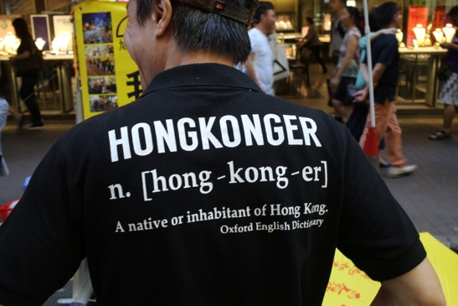
Hong Kong, 2015, ©Adam Jaworski

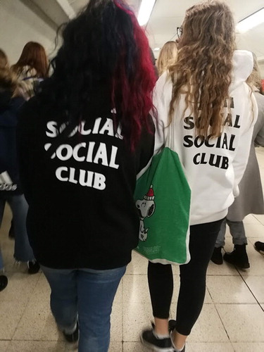
London, 2019, ©Jackie Jia Lou.


London, 2019, ©Jackie Jia Lou.
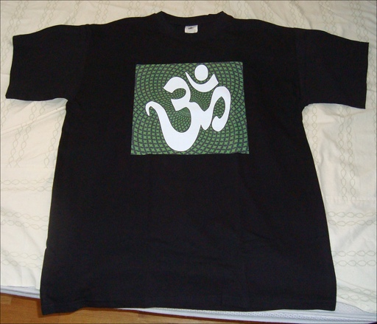
Photo credit: David J (CC BY 2.0)
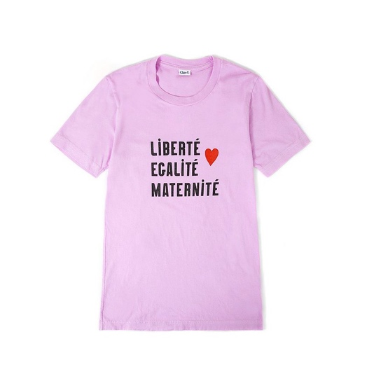
Photo credit: Heidi de Vries (CC BY 2.0)

Now watch Dr Jackie Jia Lou talk about her project on ‘wearable text’.

