Chapter 1

Additional activity

Verbal hygiene

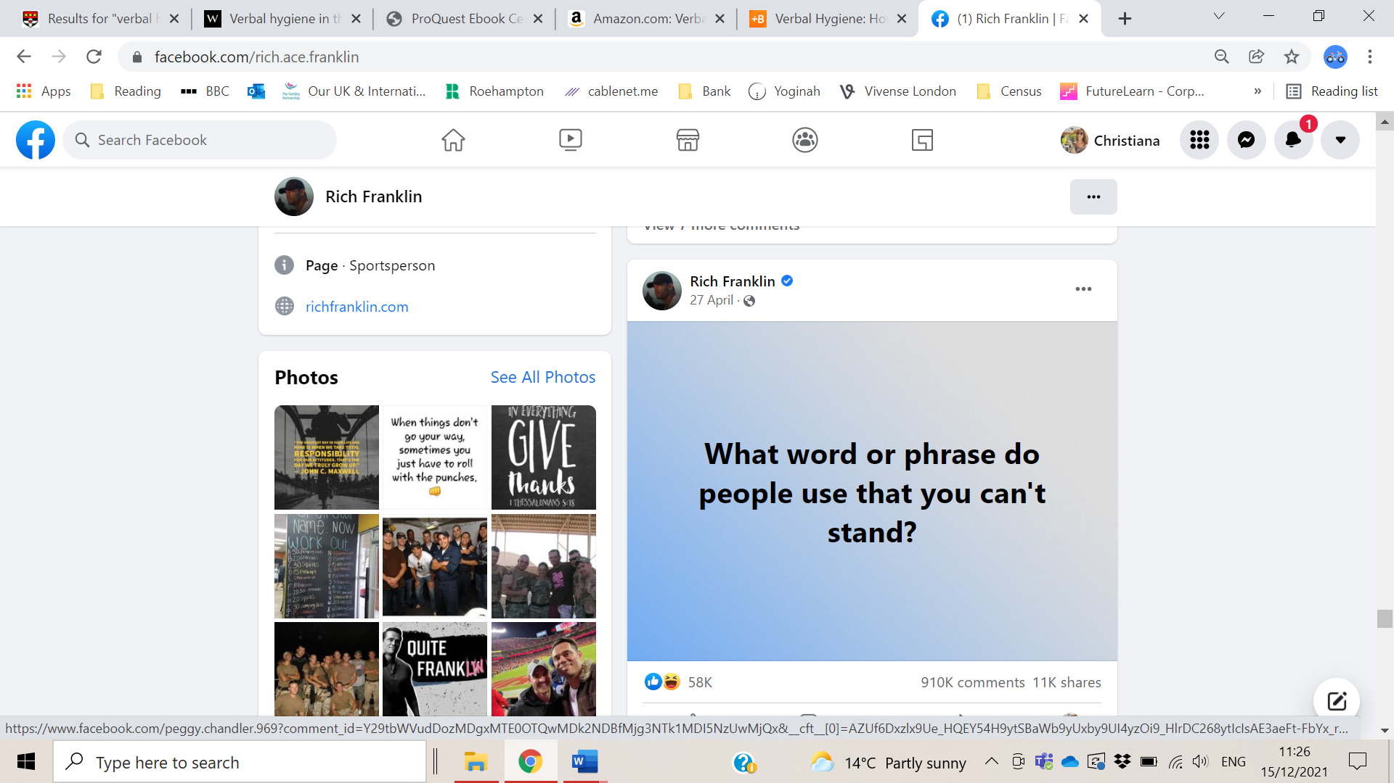

In April 2021 a famous sportsperson posted the question above on their Facebook page. The post went viral receiving 58 thousand likes, 11 thousand shares and 910 thousand comments. Opinions about various features of language were expressed by their followers, and some illustrative comments include:

- “At the end of the day.” The most overused phrase in America today. STOP IT!
- “No problem” instead of “you’re welcome.”
- I’m no grammarian, but it always bugs me to hear people say “irregardless”.
- When people use the "F" bomb every other word in a sentence
- Drives me crazy when people use "seen" wrong. For goodness sake, you saw it!
- Being the grandmother of a granddaughter with Down Syndrome I can't tolerate people calling other retards. That is a derogatory use of the word.
- I could care less.......what you really mean is I couldn't care less.
- Any sentence that ends with a preposition. Such as "Where is he at".
- "Should of" instead of “Should have”!
- When someone calls their significant other "bae" or "boo"
- When people don’t pronounce the “t” in words. I even hear news announcers do this.
Mountain
Mou-in
Forgotten
Forgo-en
This is a relatively new thing and I hate it.
- Conduct your own survey with your own contacts to collect similar examples of verbal hygiene.
- Categorise the language features that were commented upon based on whether they are grammatical, phonological, or lexical.
- Are there any recurring language features in the comments?
- Compare your findings with those of your peers.

